

Blythe Elementary School

2024-2025

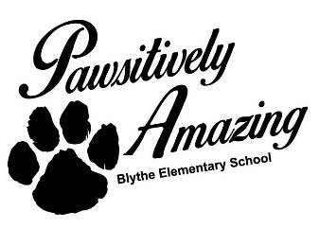

I am Ms. Chase, one of the Special Education Teachers at Blythe Elementary School. As an Interrelated Special Education Teacher, I will adapt general education lessons and teach various subject areas to students with mild and moderate disabilities. I will work closely with general education teachers, actively involved, and engaged in all aspects of instruction to support students with disabilities.

We have expectations for our students here at Blythe Elementary. Students should come to school each day prepared to learn and preserve a positive learning environment (no fighting/bullying) allowed. If your student will be absent, please notify the school or email his/her teachers. Please update any changes made to contact information throughout the school year, address, phone numbers, and contact information for persons allowed to pick up your student from school. I look forward to working with both you and your student over the course of the school year. Please feel free to call the school during my planning time with any questions or concerns.

**Classroom** **Rituals and Routines**

* Students are expected to arrive on time for school.
* Class will start each day with a bell ringer activity and temperature check (feeling sad, happy?)
* Students should use either an agenda or notebook to keep track of all assignments and homework.

**“What’s Important”**

* Technology Use: Laptops and Desktop Computers are used for Educational Purposes Only
* No Cell Phone Use

**Positive Behavior Rewards**

Positive behavior forms will be issued to Administrative Staff throughout the school year to promote student’s participation in PBIS, a framework that promotes positive behavior and creates supportive environments in schools.

**Behavior that Interferes with Learning:**

1st offense- verbal warning

2nd offense- parent contact

3rd offense- discipline referral

**Grading Policy**:

**90-100 = A**

**80-89 = B**

**75-79 =C**

**70-74 = D**

**69 and below = F**

**School Supply List**

**2-highlighters**

**1 pack of - #2 sharpen pencils**

**4- two- pocket folders**

**1 pack of index cards**

**2 packs of notebook paper**

**1 pair of wired headphones**

**Helpful Resource Websites:**

**I Ready Lessons in Reading and Math**

**Individualized for students**

**Teacher Assigned Lessons**

**EPIC for reading materials based on Students Lexile Level**